

**Diko** Installation Guide

v1.0

Copyright 2017-2019 All rights reserved

DIKO Installation Guide v1.0

DIKO Installation & Configuration

**目錄**

1 Requirement 3

2 Install IIS Server within .net Framework 3.5.1 & 4.5 4

3 Install the Microsoft WSE 2.0 13

4 DIKO Server Core 16

5 Installing Open Office 19

6 Install “Microsoft SQL 2012 Express” 23

7 Generate software license for DIKO 36

8 Setting web.config 38

9 Add Web application on IIS 39

10日 Setup and initialize Solr system 42

11 Add and install DIKO Indexing manager to Windows services 47

12 Add and install DIKO Rendition manager to Windows services 52

13 Add and install DIKO Email Capturing to Windows services 57

14 Add and install DIKO Email Capturing Pro to Windows services 62

15 Add and install DIKO Sync Folder Mass Monitor to Windows services 68

16 Browse and login DIKO 75

DIKO Installation Guide v1.0

# 1 Requirement

操作系統

* MS Windows Server 2008 / 2012 / 2016 / 2019

Database

* MSSQL Server 2008 / 2012

組件

* + IIS Server 7.0 / 8.0 / 9.0 / 10.0
  + .net Framework 3.5 sp1 (required by Microsoft SQL Express 2012)
  + .net Framework 4.5
  + Microsoft WSE 2.0 SP3 (mandatory)

User Access / Permission for installation

* + Administrator

DIKO Installation Guide v1.0

# 2 Install IIS Server within .net Framework 3.5.1 & 4.5

2.1 Open “**Server Manager**”

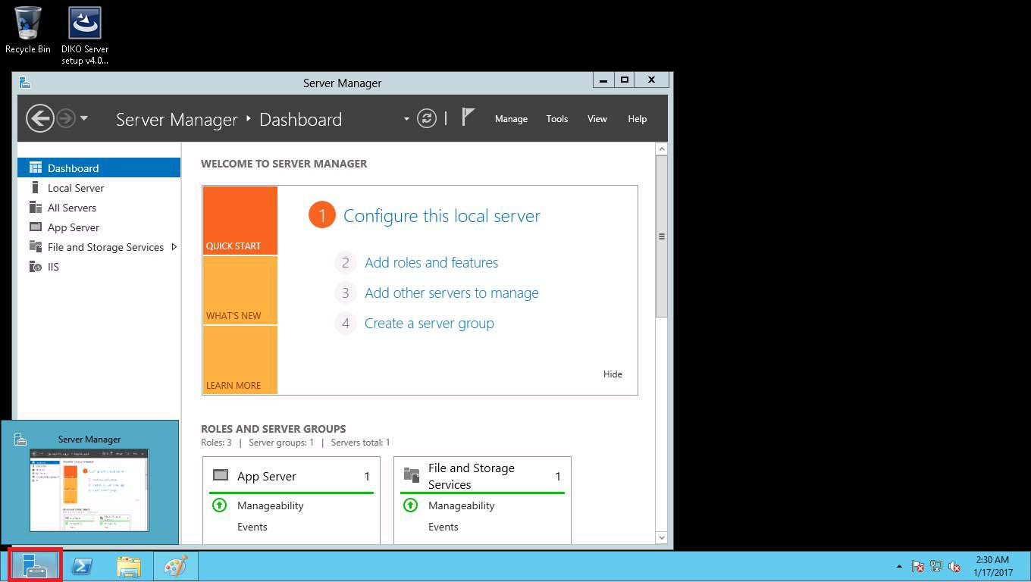

2.2 Select “**Manage**”, and select “**Add Roles and Features**”

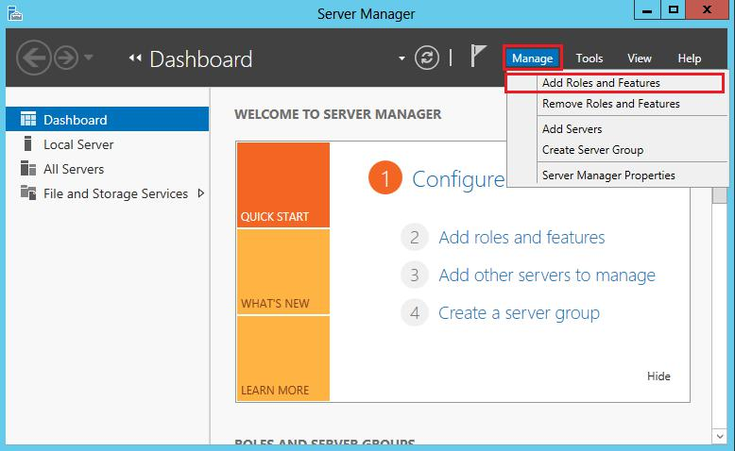

DIKO Installation Guide v1.0

2.3 Click [**Next**]

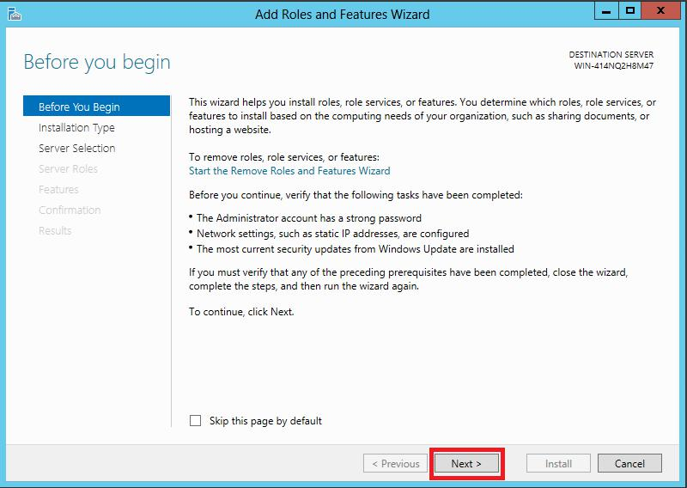

2.4 Click [**Next**]

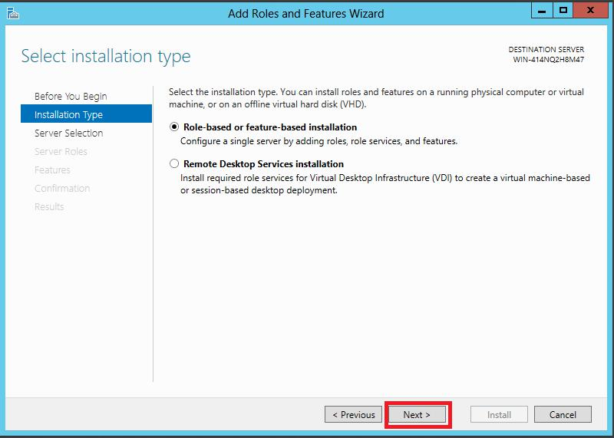

DIKO Installation Guide v1.0

2.5 Click [**Next**]

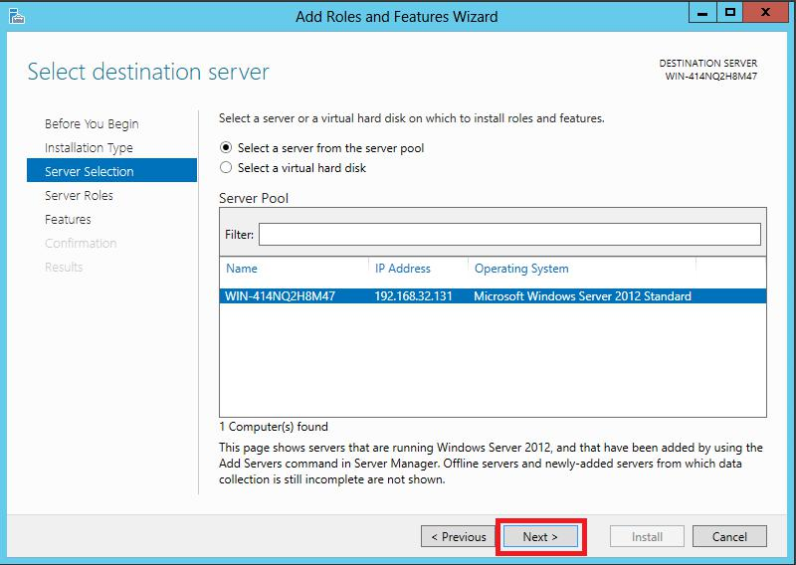

## 2.6 In “**Server Roles**”, select “**Web Server (IIS)**”; Select also “**Application Server**” for systems running Windows Server 2008 / 2012.

For Windows Server 2008 / 2012

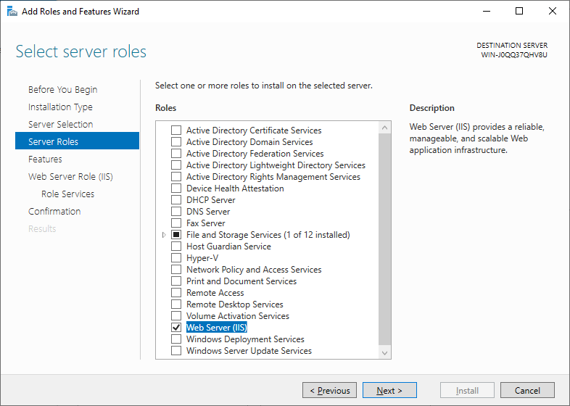

When “Web Server (IIS)” is selected, “Add Roles and Features Wizard” pops up. Click “Add Features” and then click [Next]

For Windows Server 2016 / 2019

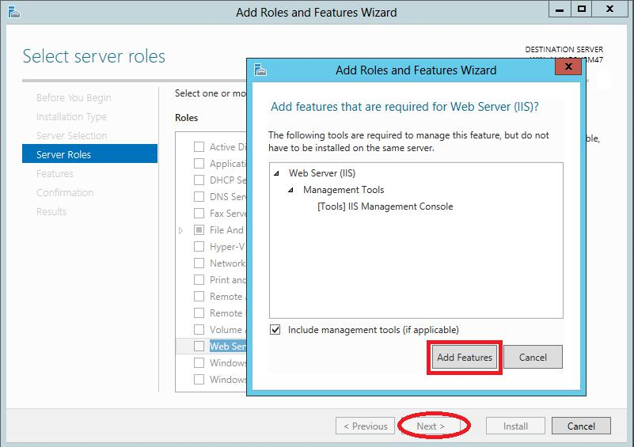

2.8 In Features, select “**.NET Framework 3.5 Features**” and “**.NET Framework 4.5 Features**”

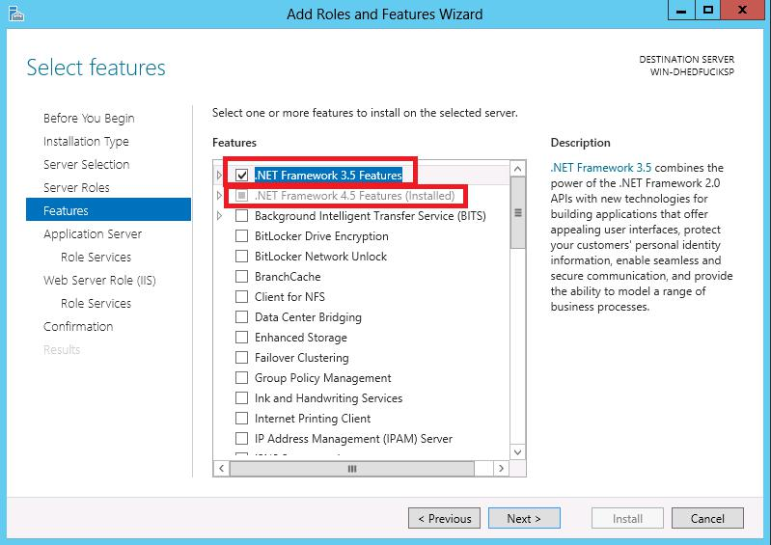

DIKO Installation Guide v1.0

2.9 Click “**Role Services**” and then select “**.NET Framework 4.5**” and “**TCP Port Sharing**”

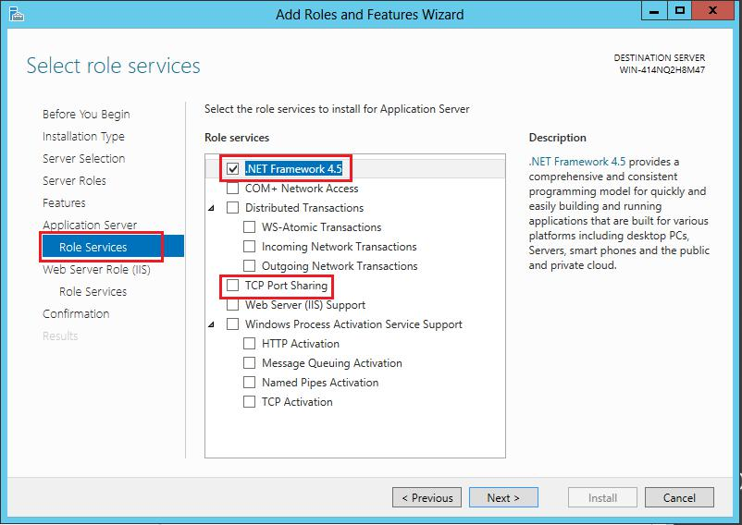

DIKO Installation Guide v1.0

2.10 Click on “**Role Services**”

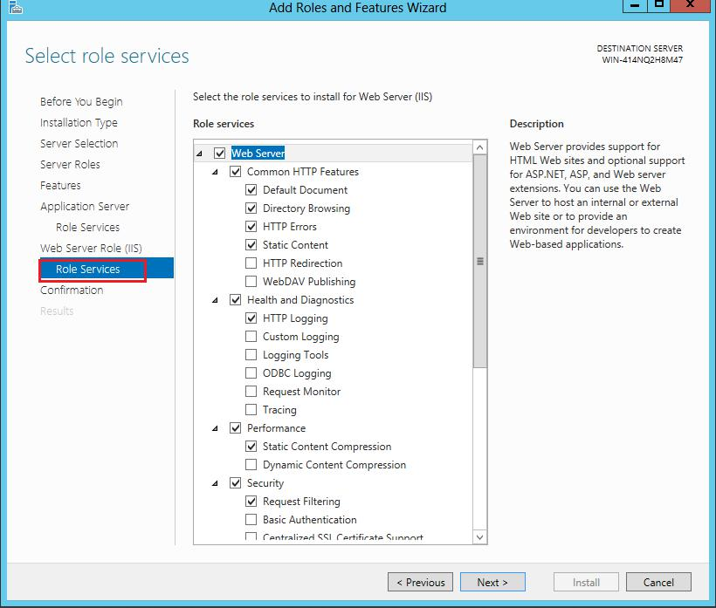

DIKO Installation Guide v1.0

2.11 **Scroll down** to Expand “Application Development”, select “.Net Exensibility3.5”, “ASP.NET 3.5”, “ISAPI Extensions”, “ISAPI Filters”, then click [**Next**]

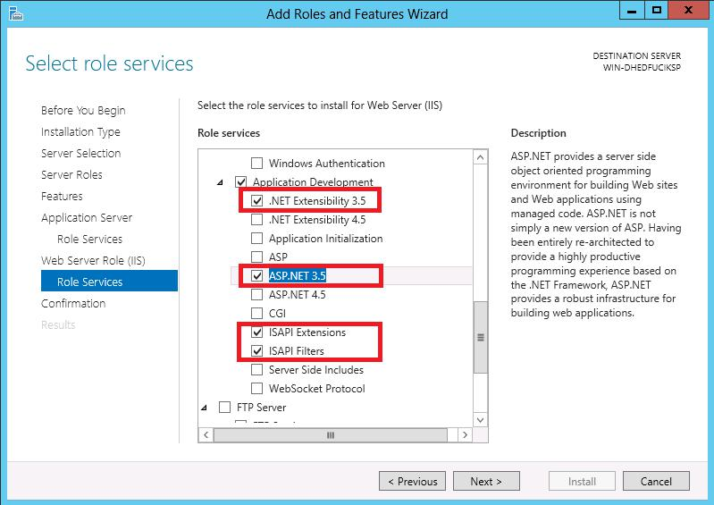

2.11.1 When “**.net Extensibility 3.5**” is selected, “**Add Roles and Features Wizard**” pops up. Click [**Add** **Features**]

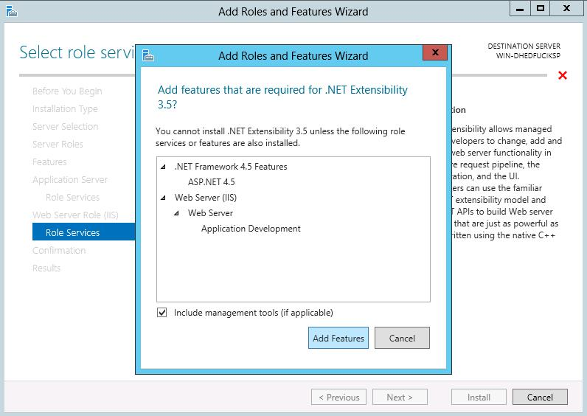

DIKO Installation Guide v1.0

2.11.2 When “**ASP .NET 3.5**” is selected, “**Add Roles and Features Wizard**” pops up. Click [**Add Features**]

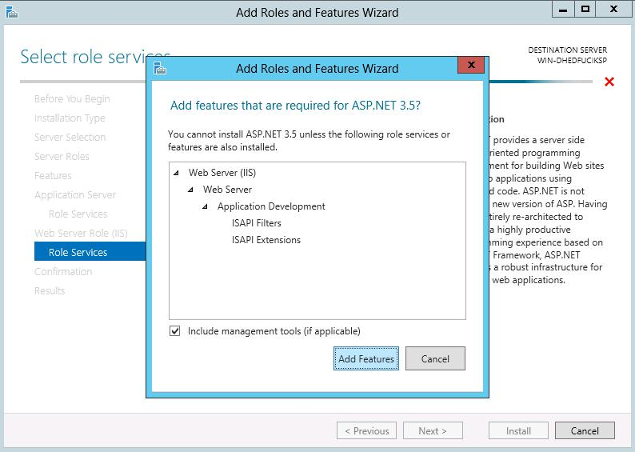

2.12 Click [**Install**] on Confirmation

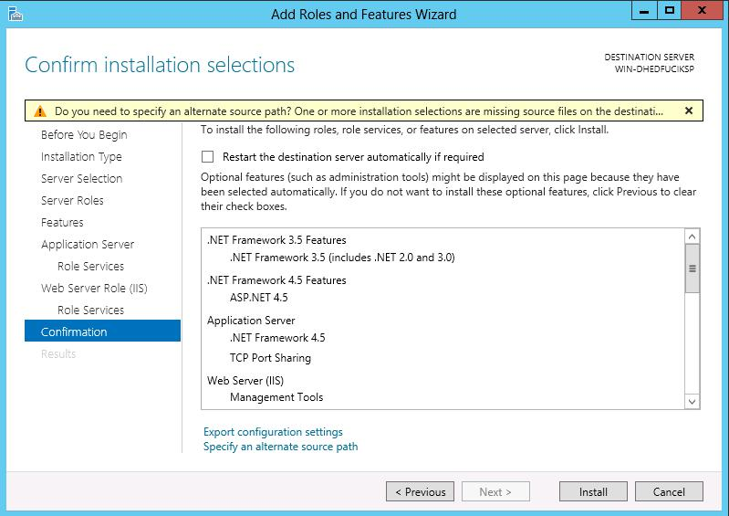

DIKO Installation Guide v1.0

2.13 After installation, click [**Close**]

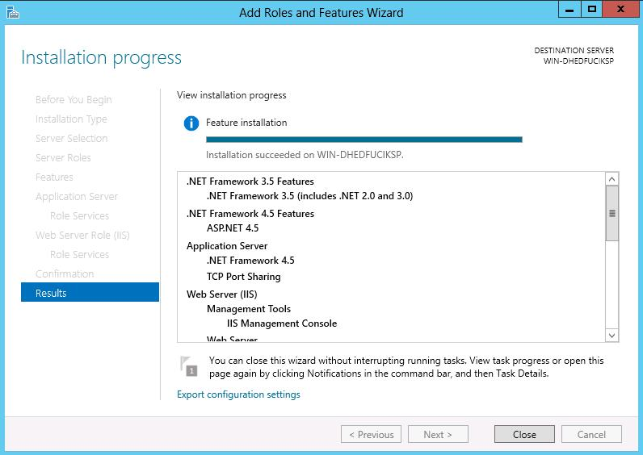

DIKO Installation Guide v1.0

**3 Install the Microsoft WSE 2.0**

3.1 Double click “Microsoft WSE2.0 SP3”, and click [Next]

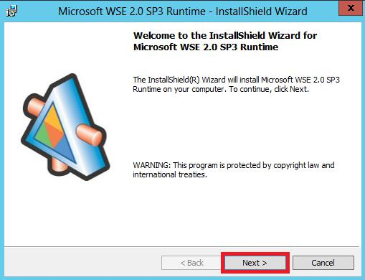

3.2 Select “I accept the terms in the license agreement” and click [Next]

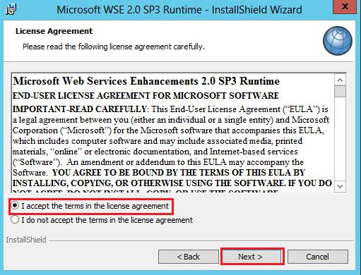

DIKO Installation Guide v1.0

3.3 Select “Runtime” and click [Next]

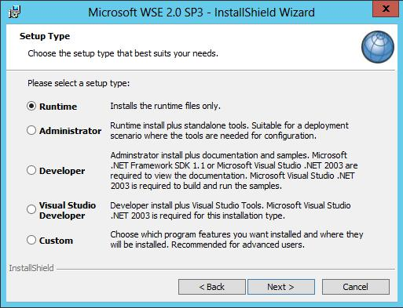

3.4 Click [Install]

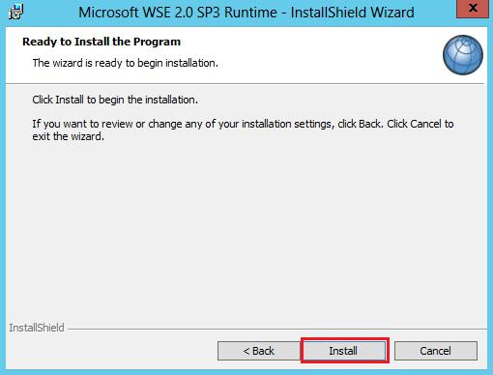

DIKO Installation Guide v1.0

3.5 Click [Finish] after installation.

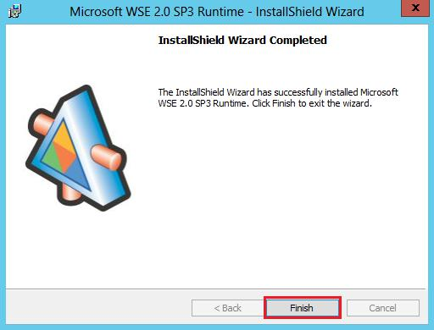

DIKO Installation Guide v1.0

1. **DIKO Server Core**

4.1 Double click “DIKO setup.exe” to run the setup wizard, and click [**Next**]

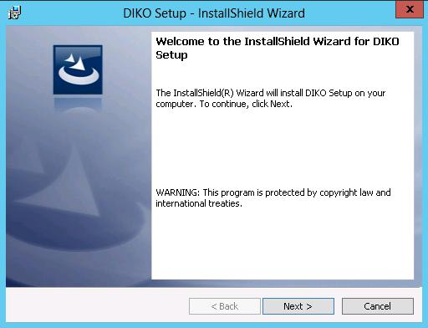

4.2 Check the box “I accept the terms in the license agreement”, and click [**Next**]

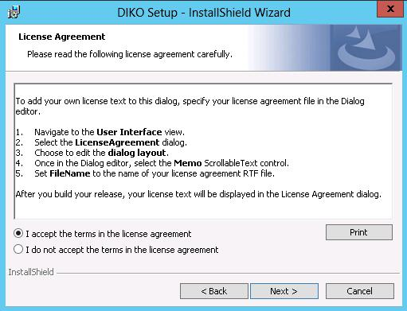

DIKO Installation Guide v1.0

4.3 Change to install to a different folder if needed, then click [**Next**]

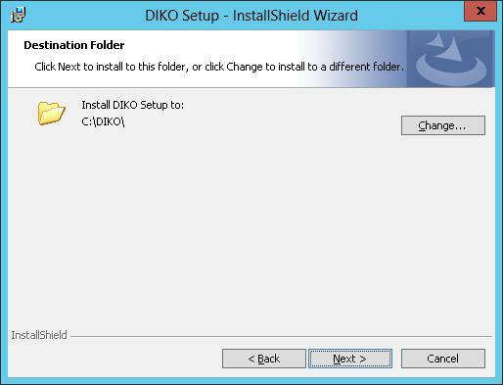

4.4 Click [**Install**]

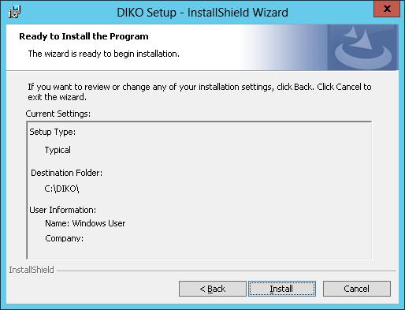

DIKO Installation Guide v1.0

4.5 Wait for Installation

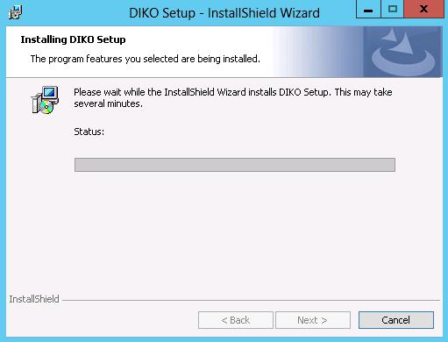

4.6 Click [**Finish**]

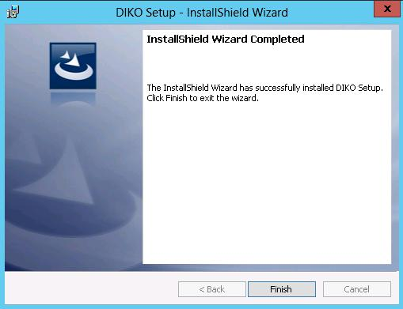

DIKO Installation Guide v1.0

**5 Installing Open Office**

5.1 Open OOO3_4_1 folder under installed DIKO directory and double click to run Setup.exe

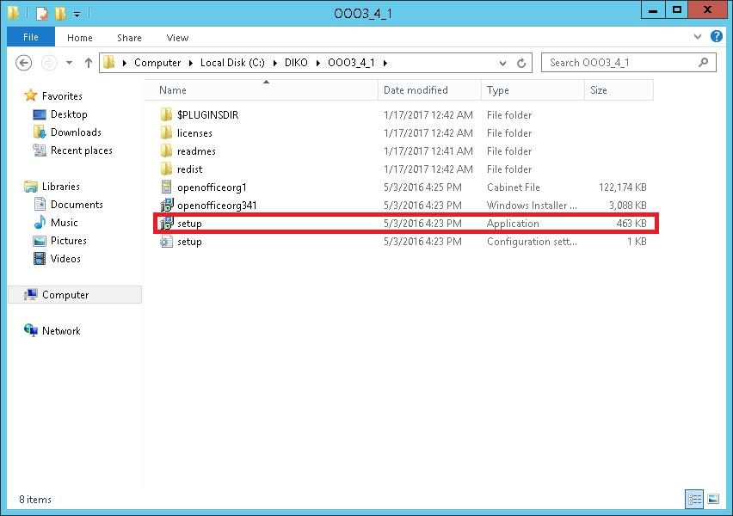

5.2 Click [Next>]

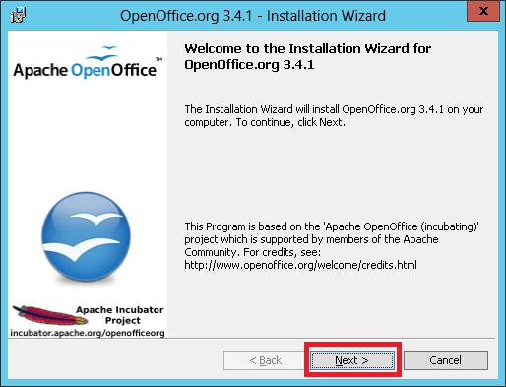

DIKO Installation Guide v1.0

5.3 Enter your information if needed and Click [Next>]

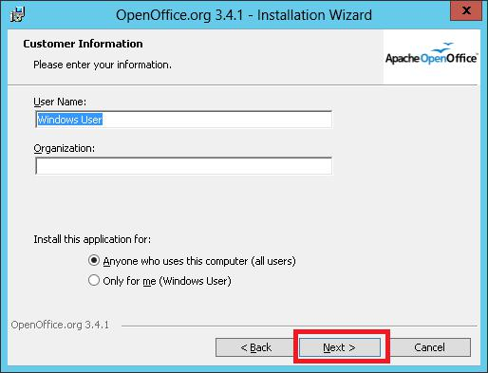

5.4 Click [Next>]

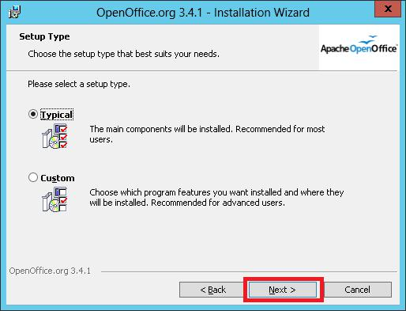

DIKO Installation Guide v1.0

5.5 Click [Install]

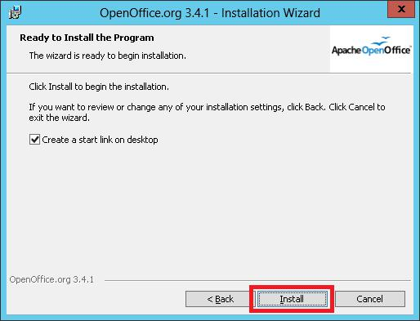

5.6 Wait for the installation

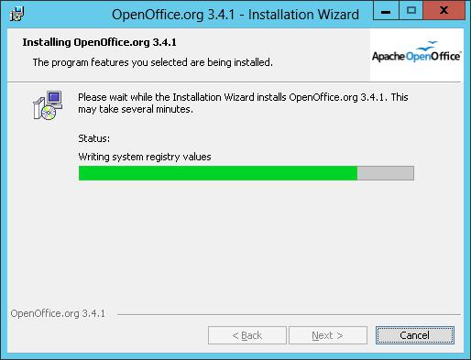

DIKO Installation Guide v1.0

5.7 Click Finish after the installation

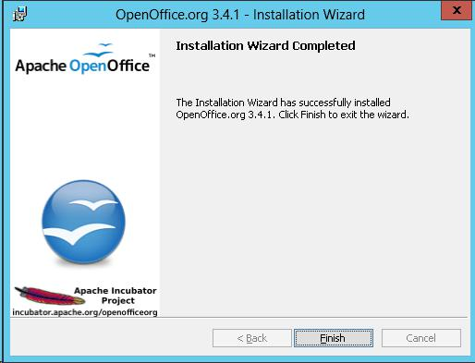

# 6 Install “Microsoft SQL 2012 Express”

## 6.1 Microsoft® SQL Server® 2012 Express is a powerful and reliable free data management system that delivers a rich and reliable data store for lightweight Web Sites and desktop applications. You can download Microsoft SQL Express from the website of Microsoft at: <https://www.microsoft.com/en-us/download/details.aspx?id=50003> Start SQLEXPRADV_x64_ENU.exe (1.9 GB) you downloaded. The system will extract the downloaded file before it can run the installation.

## 6.2 Select “Installation” > “New SQL Server Stand-alone installation or add features to an existing installation” when you got the screen below: Sometimes your server may need your response before you can continue, like this: Otherwise, you shall come to the next licensing screen below.

## 6.3 Checked the check box of “I accept the license terms and click [Next>].

## 6.4 Click [Next>]

## 6.5 Waiting for the processing

## 6.6 Click [Next>] to accept the default features:

## 6.7 Click [Next>] to accept the default names:

## 6.8 Select the “Collation” tab page to change the sorting sequence:

## 6.9 Click [Customize]

## 6.10 Click “Windows collation you would like to use:” first. Then select “Chinese_Hong_Kong_Stroke_90” and checked the “Accent-sensitive” then click [OK]

## 6.11 Click [Next>]

## 6.12 Select the “Mixed Mode (SQL Server authentication and Windows authentication) and Click [Add Current User]. Input the “Enter password” and “Confirm password” for database, will use “p@ssw0rd” for this sample and then click [Next>]

## 6.13 Select “Install and Configure.” and click [Next>]

## 6.14 Click [Next>]

## 6.15 Waiting for the installation progress.

## 6.16 Click [Close] after progress succeeded

## 6.17 Close this “SQL Server Installation Center” screen

## After installing the DOS 6.18 Search for the “SQL Server Management Studio” installed with Microsoft SQL Server Express 2012. If you cannot find it, you can also download this tool separately at <https://go.microsoft.com/fwlink/?linkid=2088649> (524 MB). Please check and uninstall any previous installation of SQL Server Management Studio before you install a newer version.



## 6.19 Right Click at the icon. Choose “Run as administrator” to start

## 6.20 Select “Windows Authentication” for the “Authentication”, and Click [Connect]

## 6.21 Right Click on “Databases”, and select “Attach…”

## 6.22 Click “Add”

## 6.23 Select “diko.mdf” from C:\DIKO\Database and click OK

## 6.24 Click OK

## 6.25 The “diko” database was added.

1. **Generate software license for DIKO**

7.1 Double click “**GenHWBlueprint.exe**” in C:\DIKO\GenHWBlueprint folder, and input the information and click “Generate C2V File”

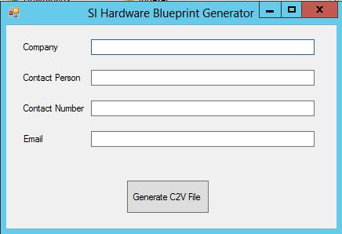

7.2 Select a destination location and click Save.

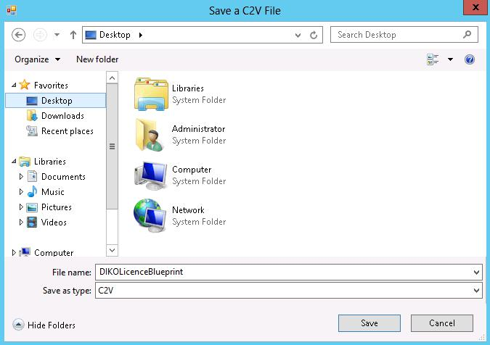

DIKO Installation Guide v1.0

7.3 Send the file **“DIKOLicence Blueprint.c2v”** back to vendor.

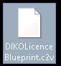

7.4 Vendor then send **“diko_license.v2c”** back to you 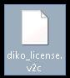, and please copy this **“diko_license.v2c”** to C:\DIKO\Properties

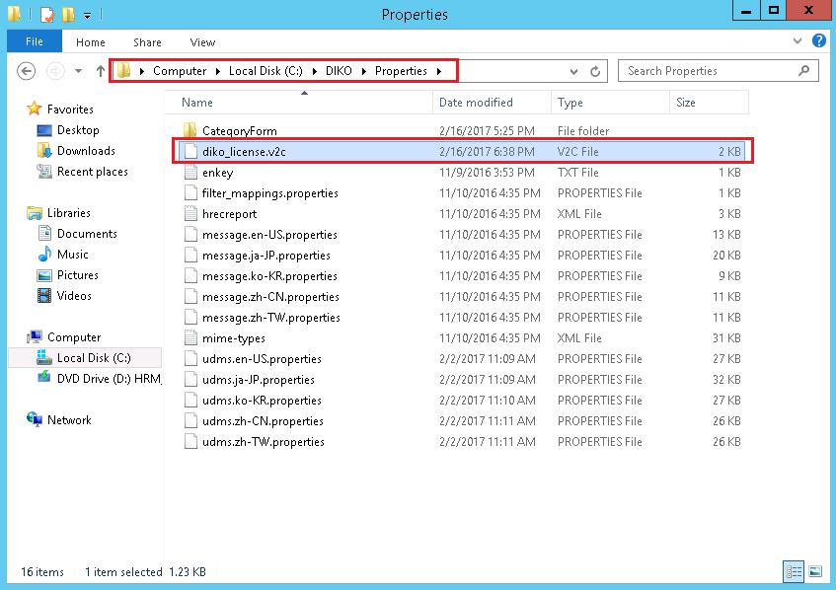

DIKO Installation Guide v1.0

**8 Setting web.config**

8.1 Go to C:\DIKO\Web, and open web.config with Notepad

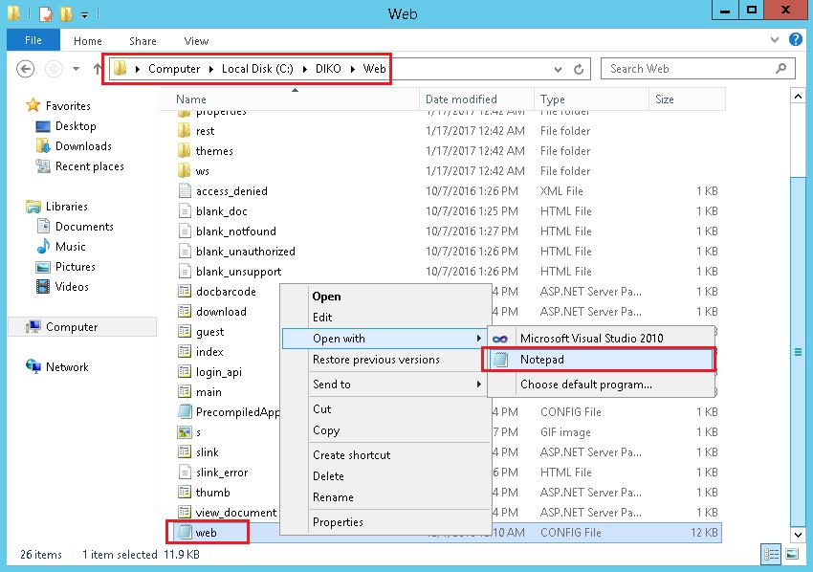

8.2 Make sure the followings are pointing to the correct path in the web.config:

<appSettings>

<add key="LogPath" value=" C:\diko\Logs\" />

<add key="RepositoryPath" value="C:\diko\Repository\" /> <add key="TempPath" value="C:\diko\Temp\" />

<add key="PropertiesDir" value="C:\diko\Properties\" />

<add key="FilterMappings" value="C:\diko\Properties\filter_mappings.properties" /> <add key="MIMEMappings" value=" C:\diko\Properties\mime‐types.xml" /> <add key="IndexPath" value="C:\ diko\Index\" />

</appSettings>

8.3 Also, change the DataSource and Password value in the connectionString to the MSSQL sa password:

<connectionStrings>

<add name="udmsmsdb" connectionString="Data Source=WIN‐DHEDFUCIKSP\SQLEXPRESS;Initial

Catalog=diko;Persist Security Info=True;User ID=sa;Password=p@ssw0rd"

providerName="System.Data.SqlClient" />

</connectionStrings>

8.4 Save the web.config file

8.5 Right click on web.config, select Properties, then go under the Security tab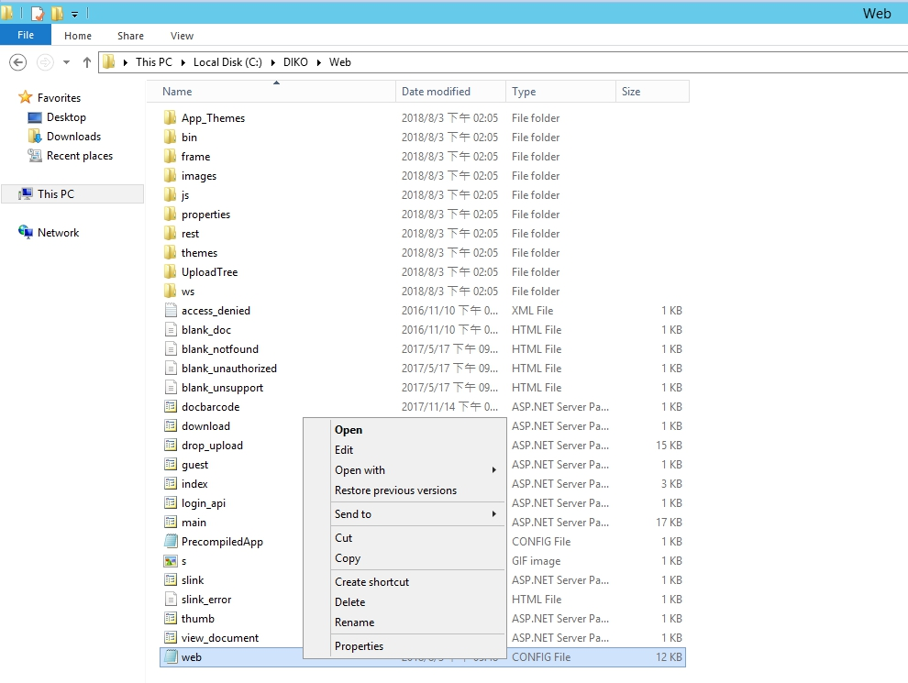

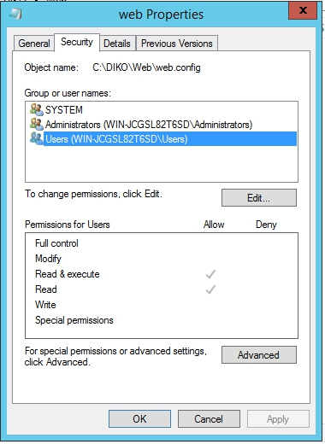

8.6 Click Edit then click Add

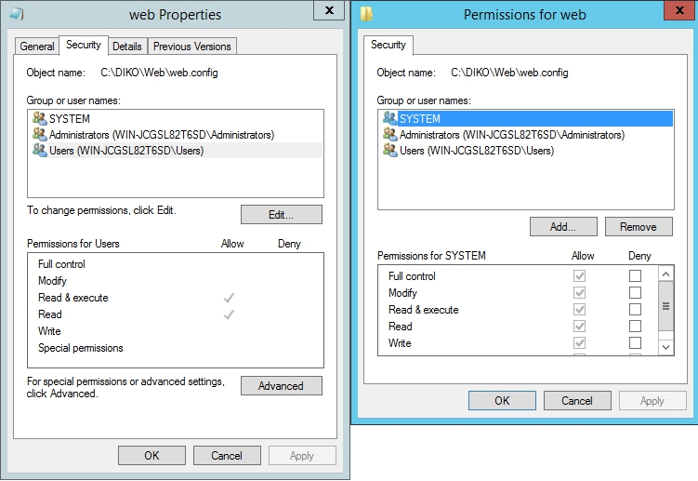

8.7 Click Advanced... then Find Now

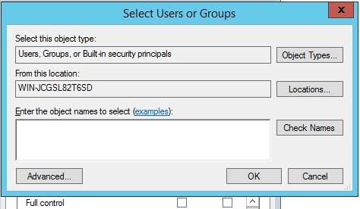

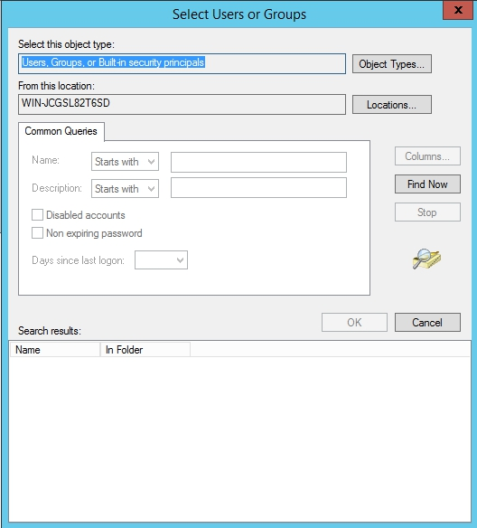

8.8 Under Find Now, look for IIS_IUSRS, then click [OK]

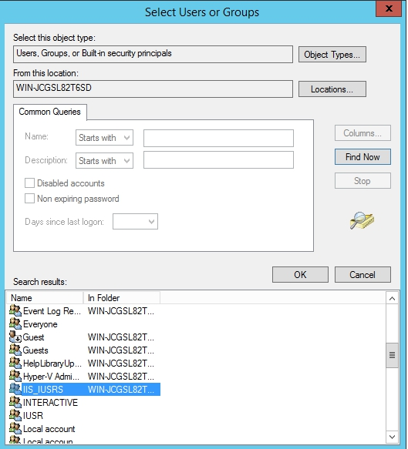

8.9 Click [OK]

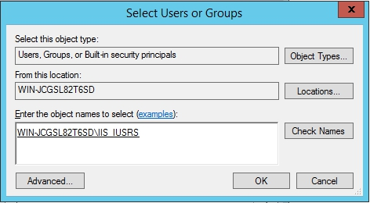

8.10 Click Allow for all of the permissions of IIS_IUSRS, then click [OK]

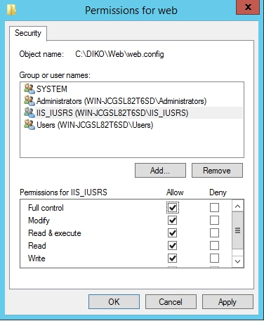

8.11 Check to see if IIS_IUSRS has all the permissions allowed, click [OK]

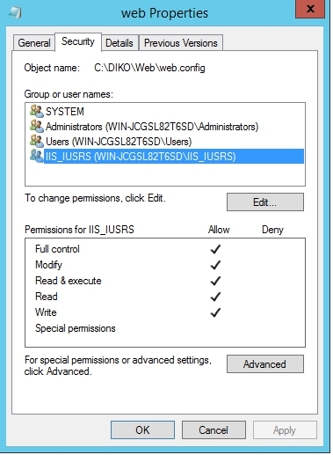

DIKO Installation Guide v1.0

**9 Add Web application on IIS**

9.1 Search “IIS Management Console”

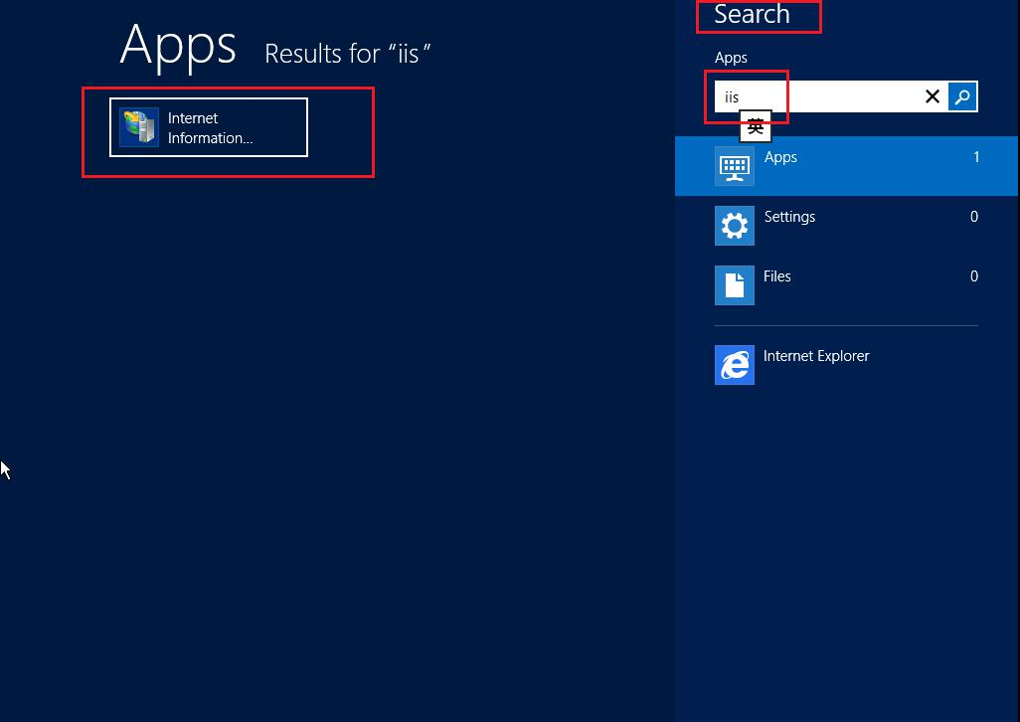

9.2 Expand the Connections tree to “Default Web Site” on the Server and right click “Default Web Site”, then select “Add Application”

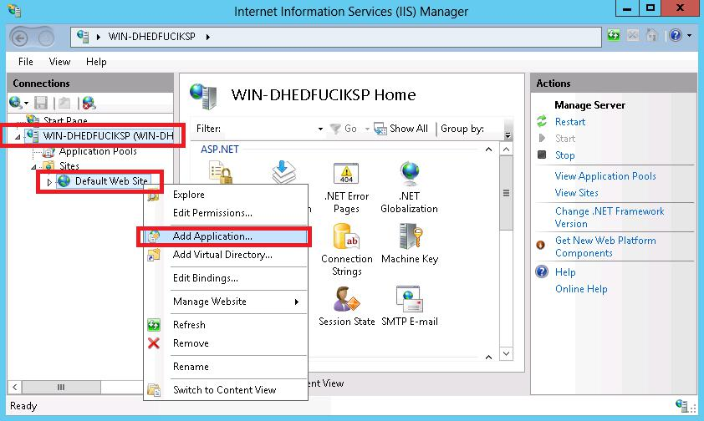

DIKO Installation Guide v1.0

9.3 Input “**diko**” as Alias, and select “**C:\DIKO\Web**” (Default installed path) as “Physical Path”, then click [**OK**]

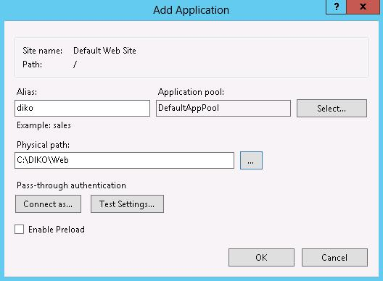

9.4 Select “**Application Pools**” on the left, then right click “**DefaultAppPool**” on the right, and select “**Advanced Settings…**”

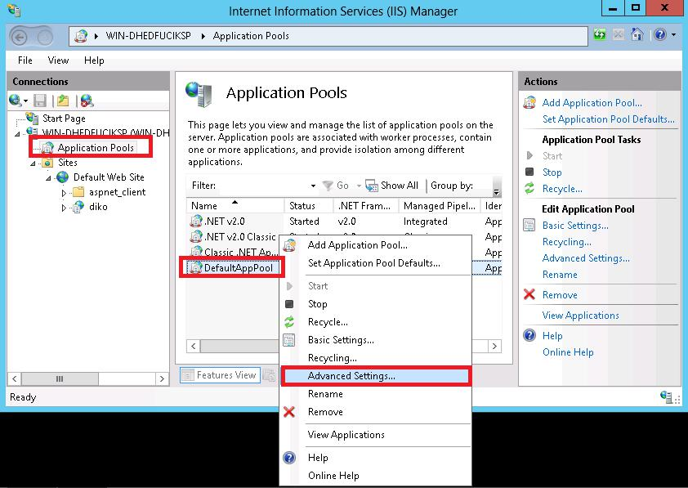

DIKO Installation Guide v1.0

9.5 Make sure “.NET Framework Version” is “V2.0” and “Enable 32bit Application Support” is “True”, then click [OK]

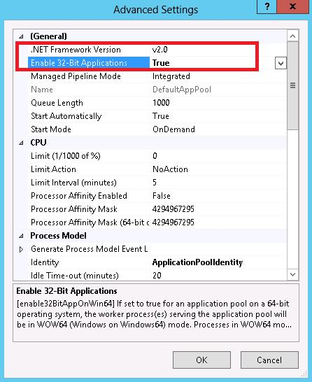

DIKO Installation Guide v1.0

**10日Setup and initialize Solr system**

10.1 Open Command Prompt as administrator in order to check installation status. Press the Windows key on your keyboard or hover the mouse to the lower right corner and click the Start button as below capture screen

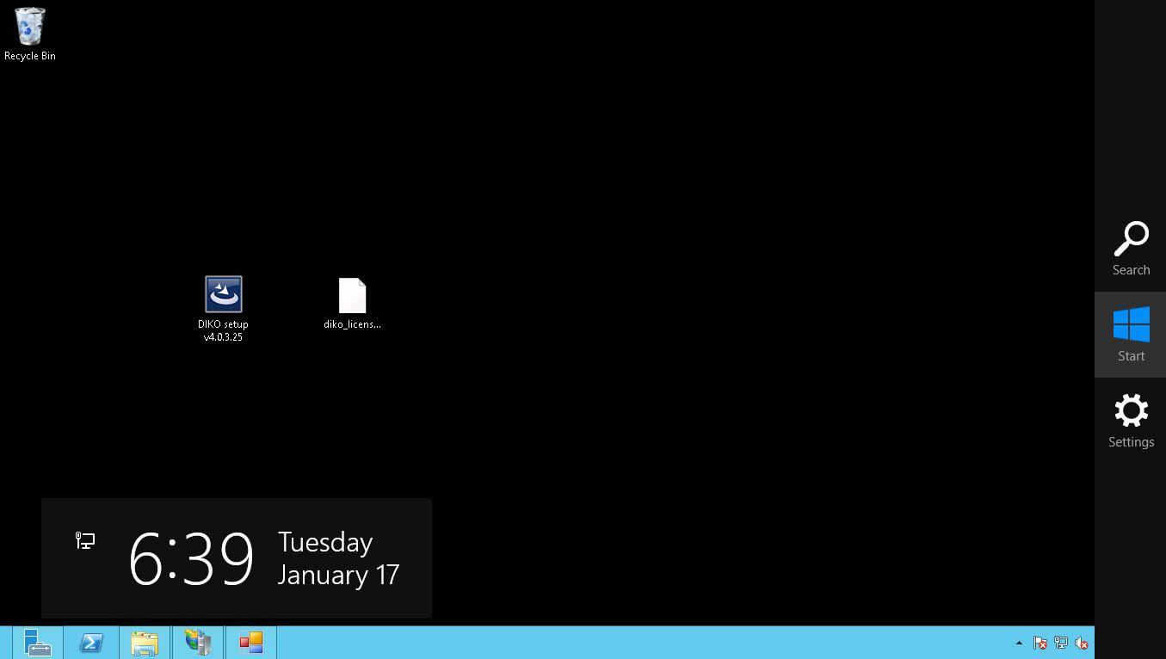

10.2 Input **cmd** on your keyboard directly, and Command Prompt program will be displayed on the left

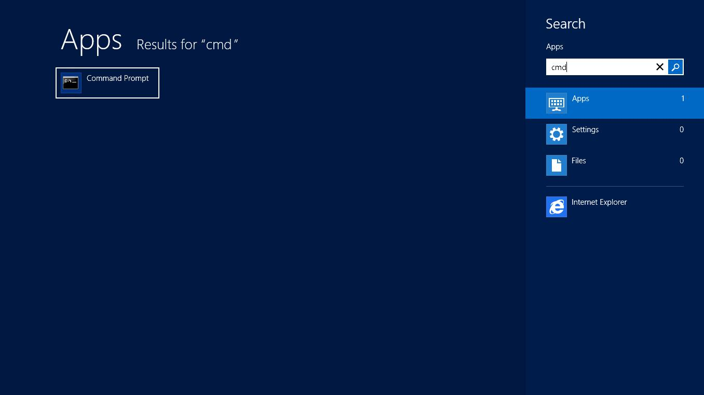

DIKO Installation Guide v1.0

10.3 Right click Command Prompt program, and select **Run as administrator at** the bottom

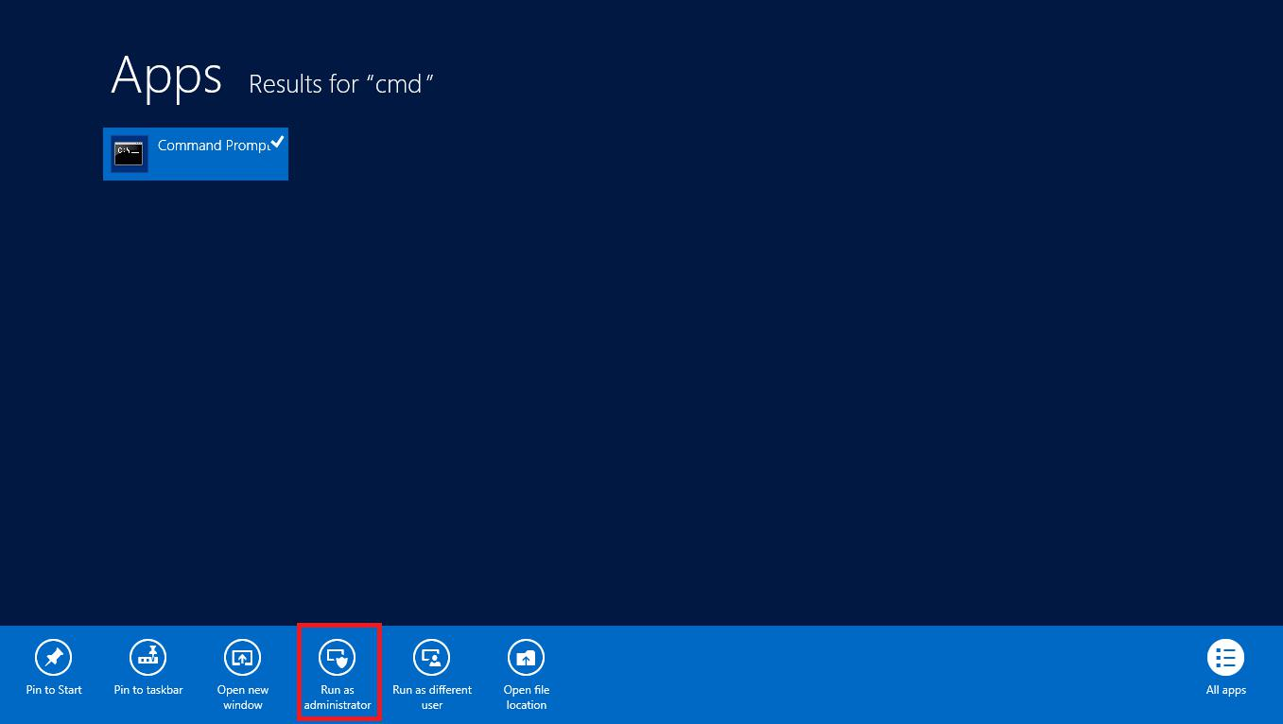

Cd \

10.4 Input **cd C:\DIKO\solr** and press Enter key to change the current directory to C:\DIKO\solr.

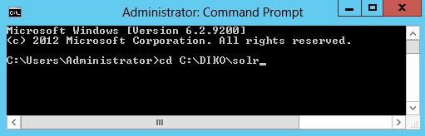

10.5 Input **nssm install Solr** and press Enter

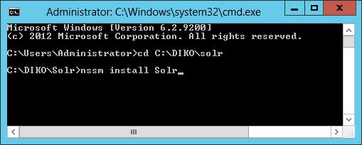

DIKnssO Installation Guide v1.0

10.6 NSSM service installer will appear as below

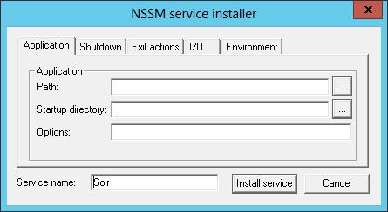

10.7 Press the [...] button for Path, and go to **C:\DIKO\solr\jdk7\bin** and select **java.exe** in order to set the path to C:\DIKO\solr\jdk7\bin\java.exe. Also the Startup directory will changed to C:\DIKO\solr\jdk7\bin

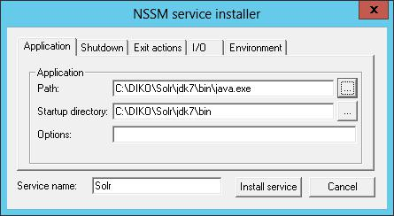

DIKO Installation Guide v1.0

10.8 In Options, input the contents inside of Option Script(Option Script can be found in DIKO's installation folder's sub folder Solr, for example: C:\DIKO\Solr)



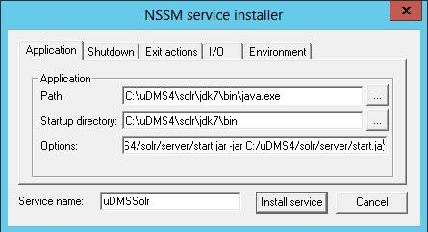

10.9 Click [Install service].

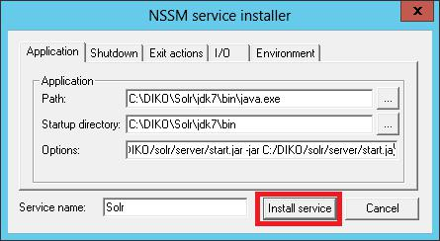

10.10 You should get a Service successfully installed message.

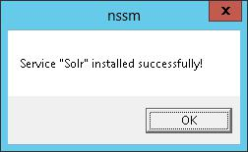

DIKO Installation Guide v1.0

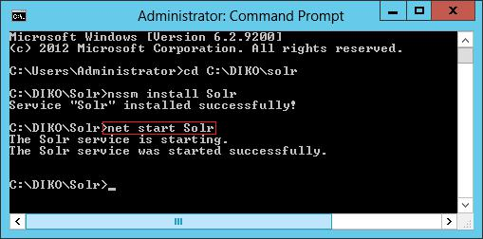10.11 Input **net start Solr** and press Enter to start Solr service. Should show the message of “The Solr service was started successful

IKO Installation Guide v1.0

1. **Add and install DIKO indexing manager to Windows services**

11.1 Go to C:\DIKO\Indexer, and open config.ini with notepad.

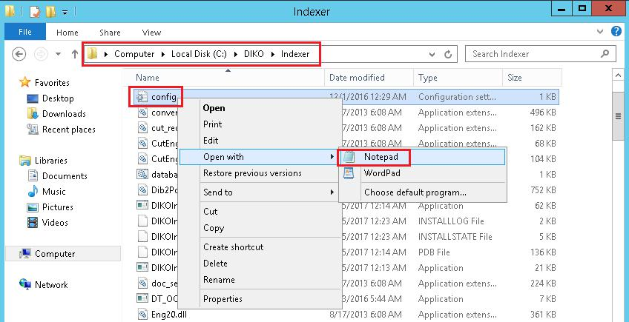

11.2 Make sure the followings are pointing to the correct path and value in the config.ini.

For use the HWOCR function, user must plug‐in the HWOCR dongle first.

Make sure the DBServer is equal to the “name of your computer”/SQLEXPRESS, you can find this information from SQL Server Management Studio’s connection screen.

|  |  |
| --- | --- |
|  | C:\Users\LP0001\AppData\Local\LINE\Cache\tmp\1541569704908.jpg |

11.3 Open Command Prompt as administrator in order to register DIKO Indexer service.

11.4 Input **cd C:\DIKO\Indexer** and press Enter key to change the current directory to C:\DIKO\Indexer.

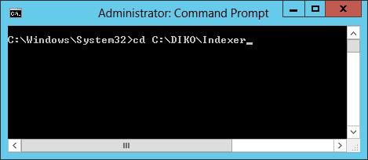

11.5 Input **"Register DIKOIndexer.bat"** and press Enter key to run the installation program.

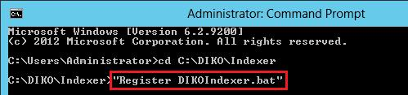

DIKO Installation Guide v1.0

11.6 If the installation is succeeded, the screen will appear message of “The transacted install has completed”

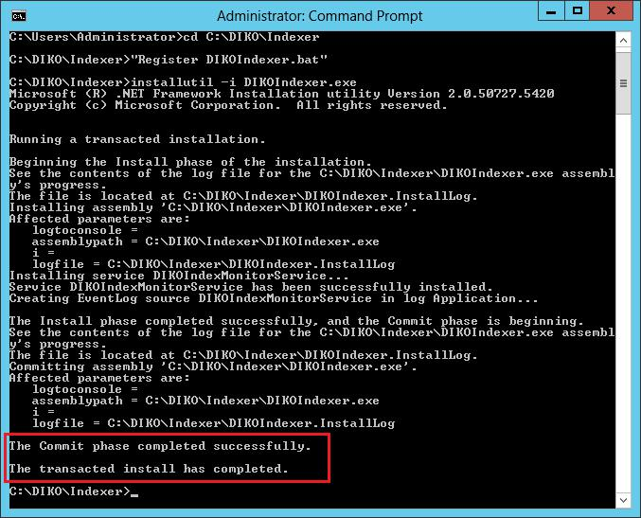

11.7 Close the Command Prompt windows.

11.8 Search “Services” and Open “Services” interface.

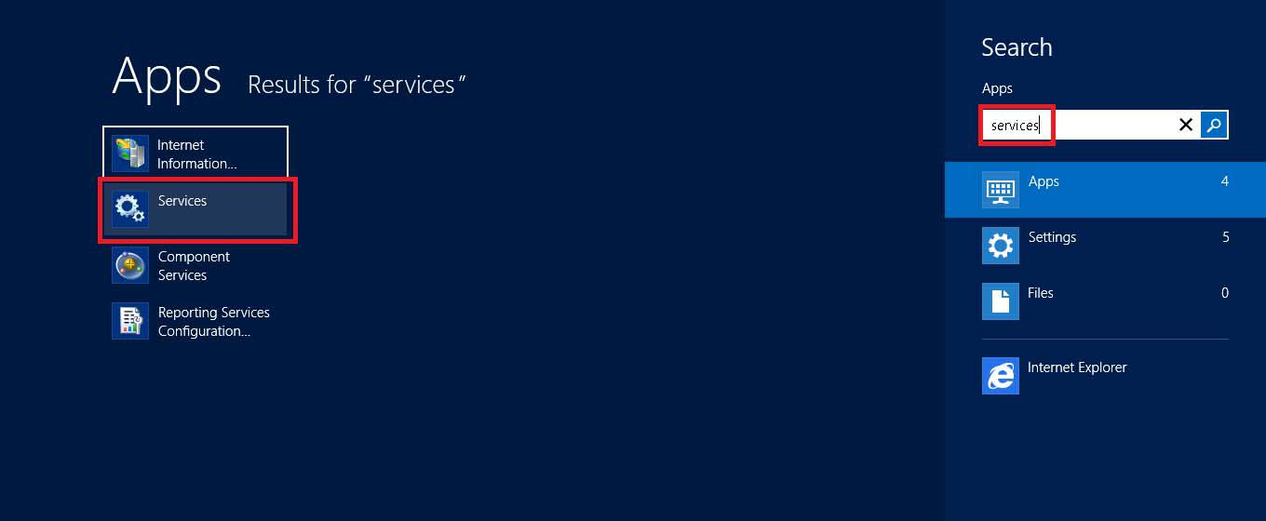

DIKO Installation Guide v1.0

11.9 Right click on the DIKO Index Monitor and select the Properties

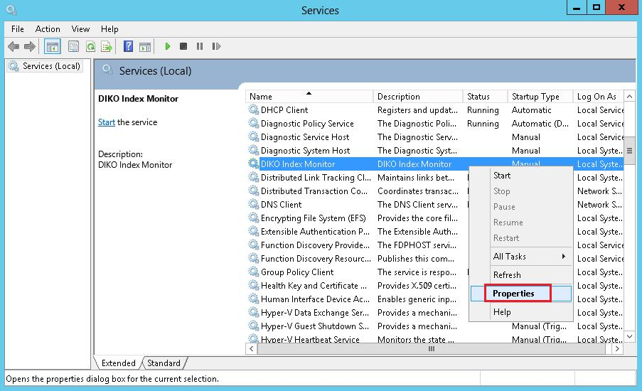

11.10 Change the Startup type to “Automatic (Delayed Start)” and Click [OK]

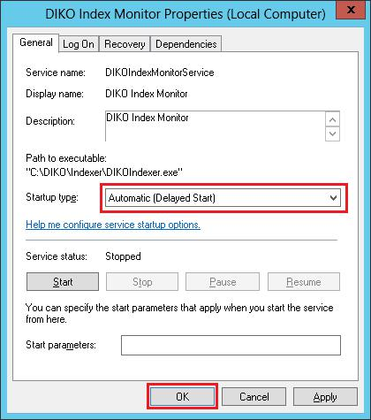

DIKO Installation Guide v1.0

11.11 Click Start to Start the DIKO Index Monitor

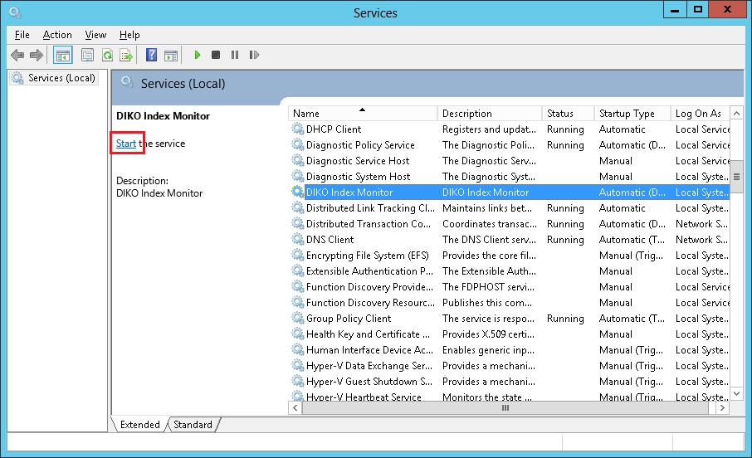

DIKO Installation Guide v1.0

1. **Add and install DIKO Rendition manager to Windows services**

12.1 Go to C:\DIKO\RenditionManager, and open config.ini with notepad.

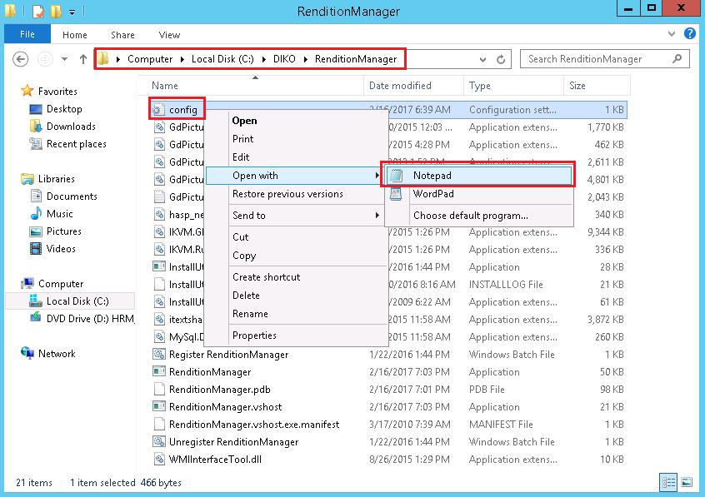

DIKO Installation Guide v1.0

12.2 Make sure the followings are pointing to the correct path and value in the config.ini

Make sure the DBServer is equal to the “name of your computer”/SQLEXPRESS, you can find this information from SQL Server Management Studio’s connection screen.

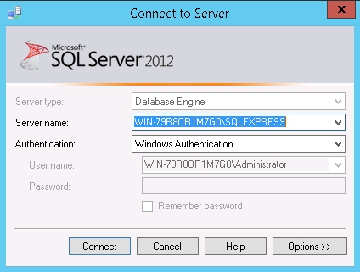

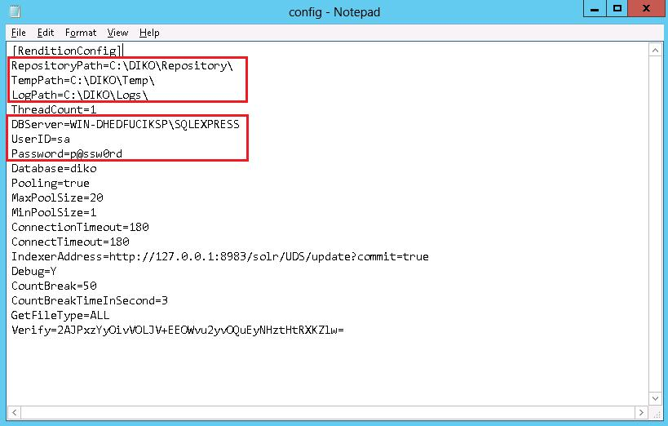

12.3 Open Command Prompt as administrator in order to register DIKO Rendition Manager service

12.4 Input **cd C:\DIKO\RenditionManager** and press Enter key to change the current directory to C:\DIKO\RenditionManager.

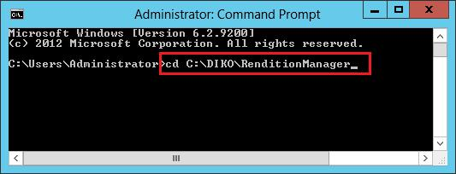

DIKO Installation Guide v1.0

12.5 Input **"Register RenditionManager.bat"** and press Enter key to run the installation program.

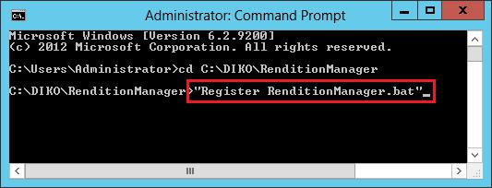

12.6 If the installation is succeeded, the screen will appear message of “The transacted install has completed”

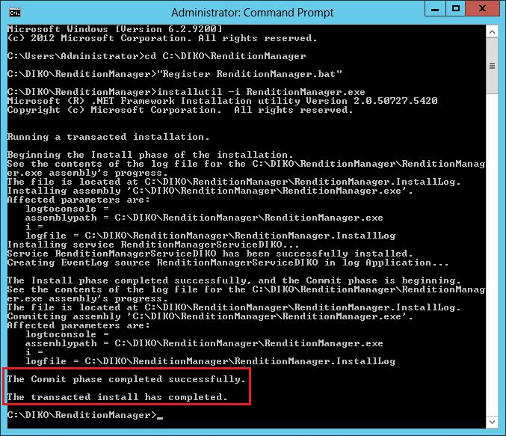

12.7 Close the Command Prompt windows.

DIKO Installation Guide v1.0

12.8 Search “Services” and Open “Services” interface.

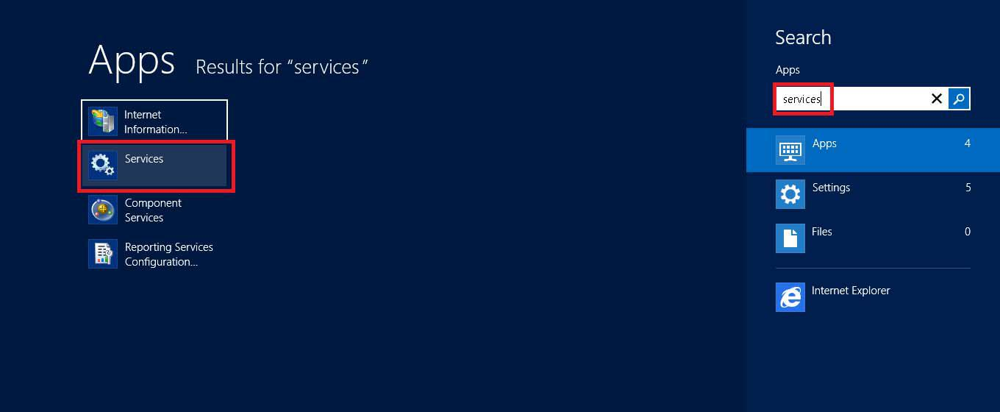

12.9 Right click on the DIKO Rendition Manager and select the Properties

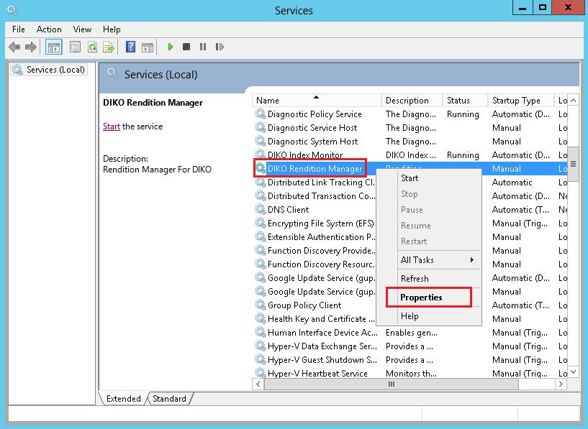

DIKO Installation Guide v1.0

12.10 Change the Startup type to “Automatic (Delayed Start)” and Click [OK]

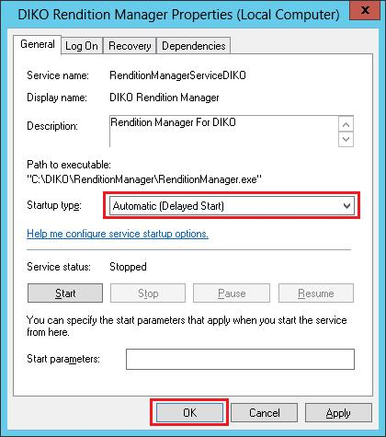

12.11 Click Start to Start the DIKO Rendition Manager

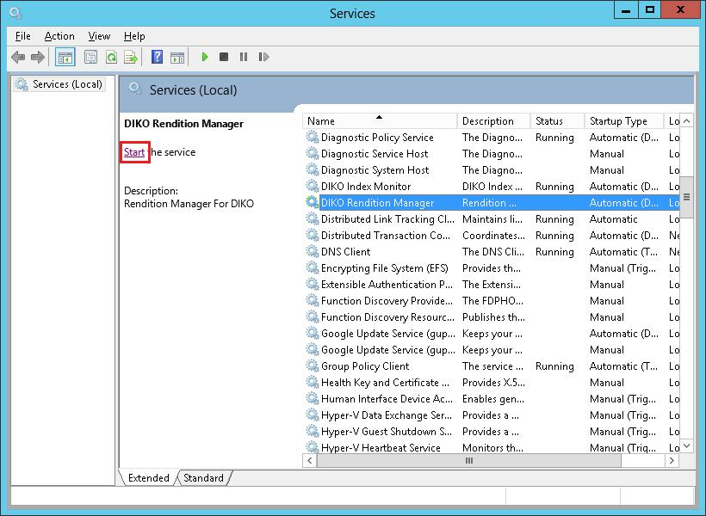

DIKO Installation Guide v1.0

1. **Add and install DIKO Email Capturing to Windows services**

13.1 Go to C:\DIKO\EmailCapturing, and open config.ini with notepad.

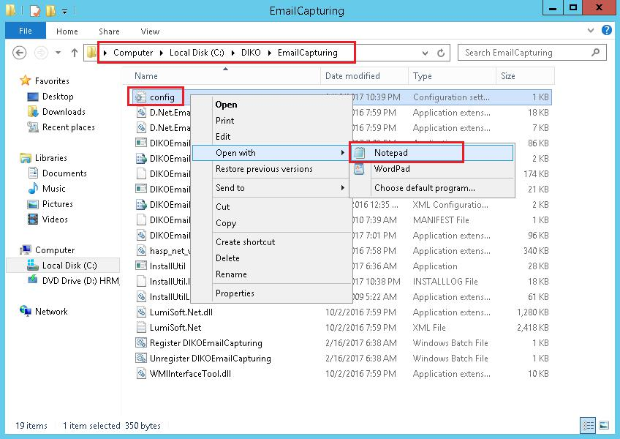

13.2 Make sure the followings are pointing to the correct path and value in the config.ini

Make sure the DBServer is equal to the “name of your computer”/SQLEXPRESS, you can find this information from SQL Server Management Studio’s connection screen.



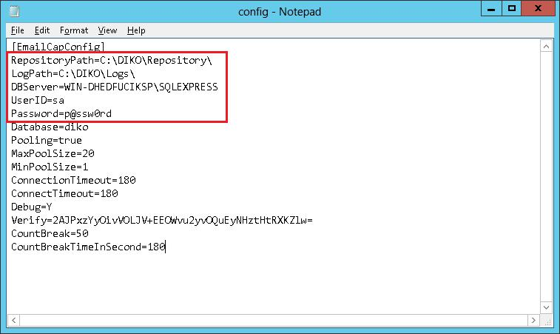

DIKO Installation Guide v1.0

13.3 Open Command Prompt as administrator in order to register DIKO Email Capturing service

13.4 Input **cd C:\DIKO\EmailCapturing** and press Enter key to change the current directory to C:\DIKO\EmailCapturing.

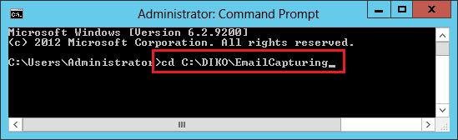

13.5 Input **"Register DIKOEmailCapturing.bat"** and press Enter key to run the installation program.

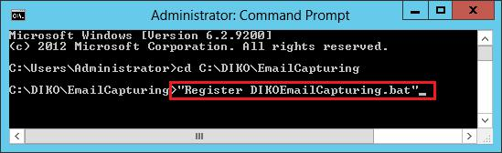

DIKO Installation Guide v1.0

13.6 If the installation is succeeded, the screen will appear message of “The transacted install has completed”

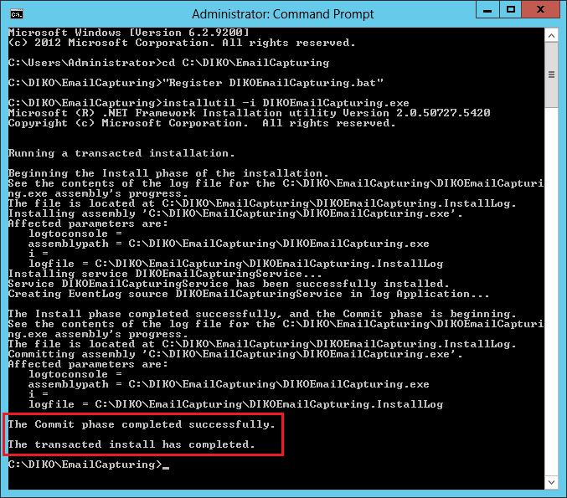

13.7 Close the Command Prompt windows.

DIKO Installation Guide v1.0

13.8 Search “Services” and Open “Services” interface.



13.9 Right click on the DIKO Email Capturing and select the Properties

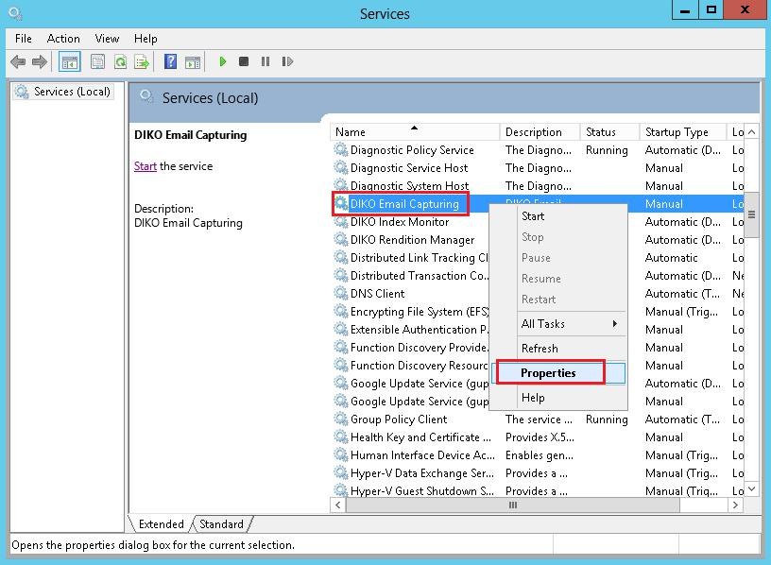

DIKO Installation Guide v1.0

13.10 Change the Startup type to “Automatic (Delayed Start)” and Click [OK]

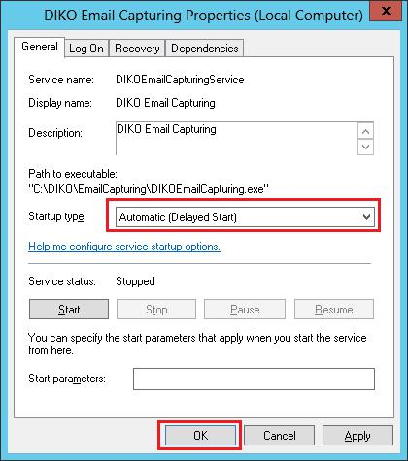

13.11 Click Start to Start the DIKO Email Capturing

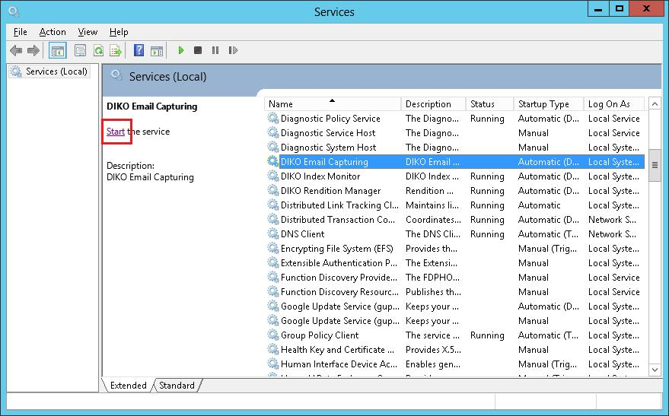

DIKO Installation Guide v1.0

**14 Add and install DIKO Email Capturing Pro to Windows services**

14.1 Go to C:\DIKO\Email Capturing Pro, and open config.ini with notepad.

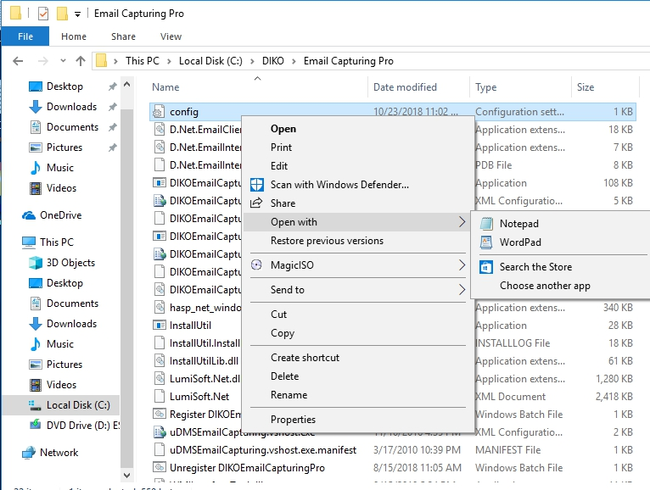

14.2 Make sure the followings are pointing to the correct path and value in the config.ini

Make sure the DBServer is equal to the “name of your computer”/SQLEXPRESS, you can find this information from SQL Server Management Studio’s connection screen.



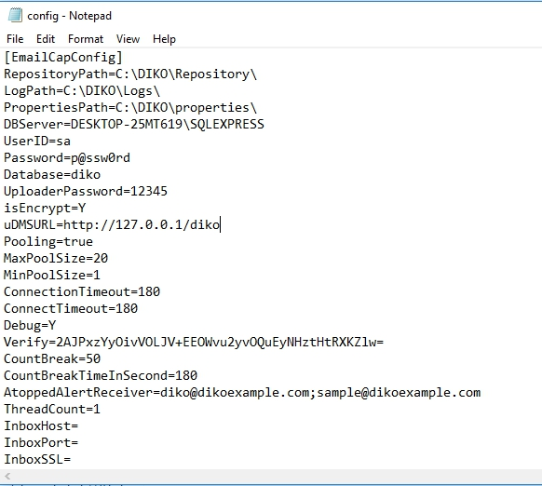

14.3 Open Command Prompt as administrator in order to register DIKO Email Capturing Pro service

14.4 Input **cd C:\DIKO\Email Capturing Pro** and press Enter key to change the current directory to C:\DIKO\Email Capturing Pro.

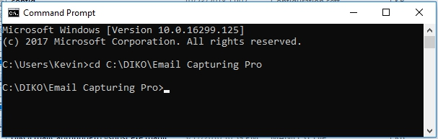

14.5 Input **"Register DIKOEmailCapturingPro.bat"** and press Enter key to run the installation program.

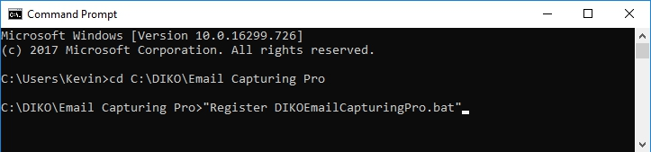

14.6 If the installation is succeeded, the screen will appear message of “The transacted install has completed”

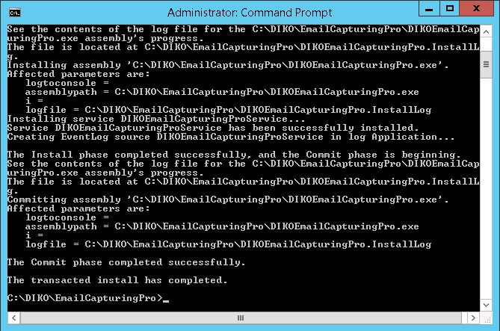

14.7 Close the Command Prompt windows.

14.8 Search “Services” and Open “Services” interface.

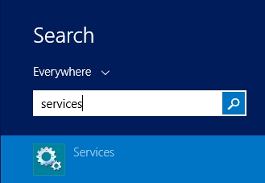

14.9 Right click on the DIKO Email Capturing Pro and select the Properties

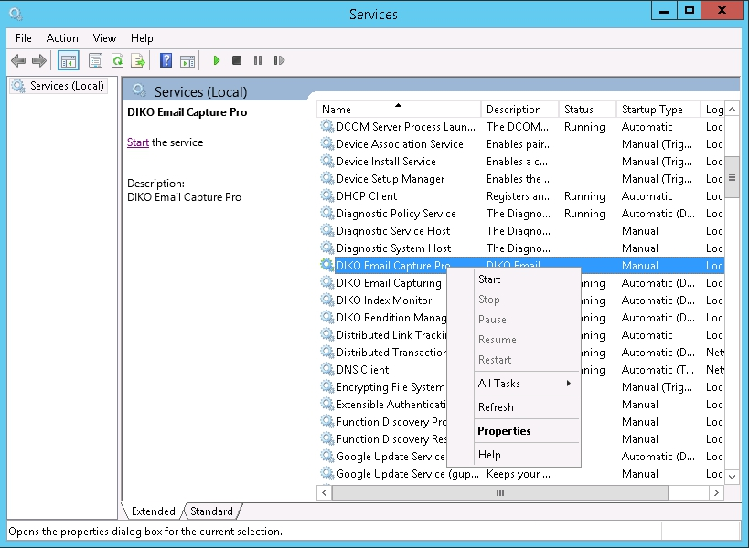

14.10 Change the Startup type to “Automatic (Delayed Start)” and Click [OK]

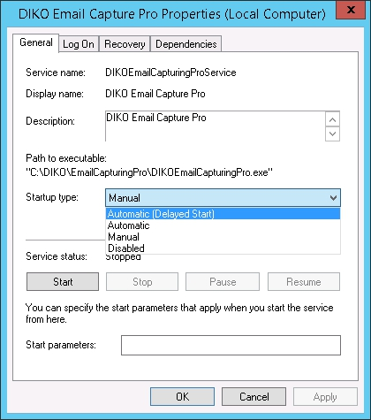

14.11 Click Start to Start the DIKO Email Capturing Pro

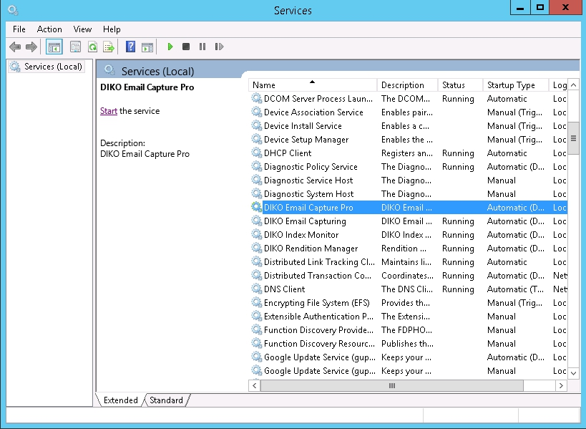

**15 Add and install DIKO Sync Folder Mass Monitor to Windows services**

15.1 Go to C:\DIKO\SyncFolderMass, and open config.ini with notepad.

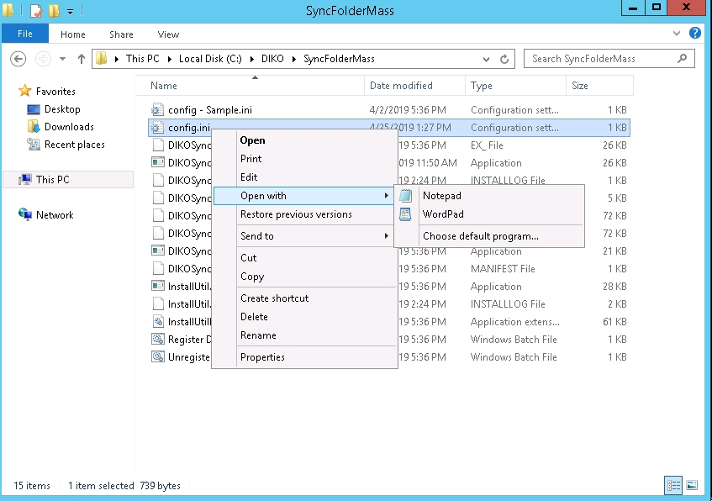

15.2 Make sure the followings are pointing to the correct path and value in the config.ini

Make sure the DBServer is equal to the “name of your computer”/SQLEXPRESS, you can find this information from SQL Server Management Studio’s connection screen.



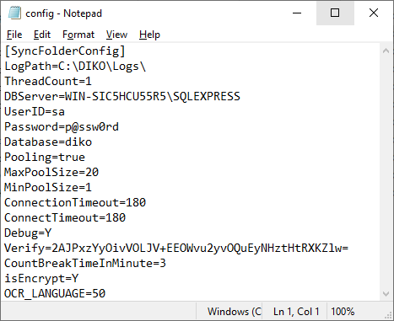

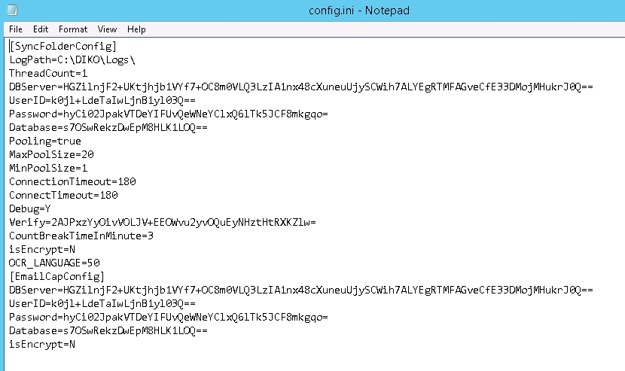15.3 Open Command Prompt as **administrator** in order to register DIKO Sync Folder Mass Monitor service

15.4 Input **cd C:\DIKO\SyncFolderMass** and press Enter key to change the current directory to C:\DIKO\SyncFolderMass.

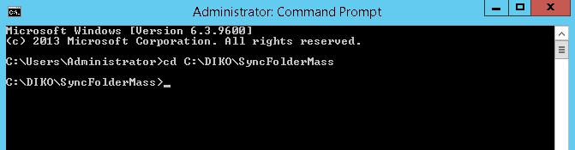

15.5 Input **"Register DIKOEmailCapturingPro.bat"** and press Enter key to run the installation program.

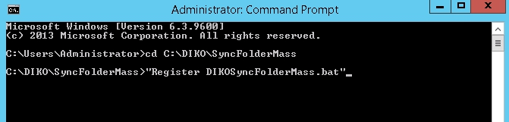

15.6 If the installation is succeeded, the screen will appear message of “The transacted install has completed”

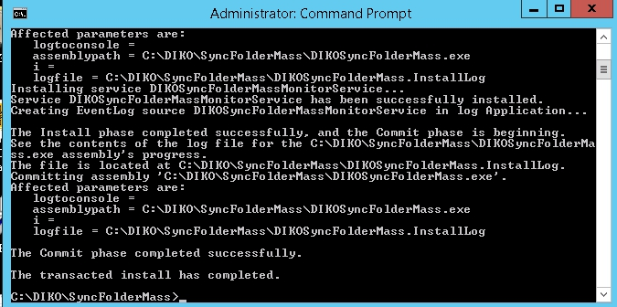

15.7 Close the Command Prompt window.

15.8 Search “Services” and Open “Services” interface.



15.9 Right click on the DIKO Sync Folder Mass Monitor and select Properties

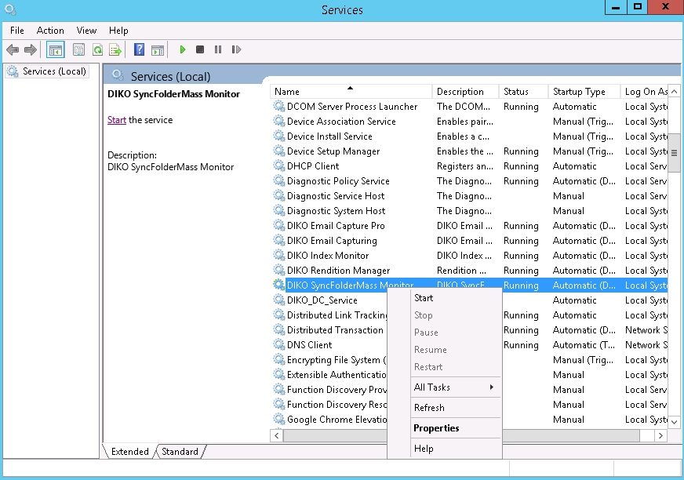

15.10 Change the Startup type to “Automatic (Delayed Start)” and Click [OK]

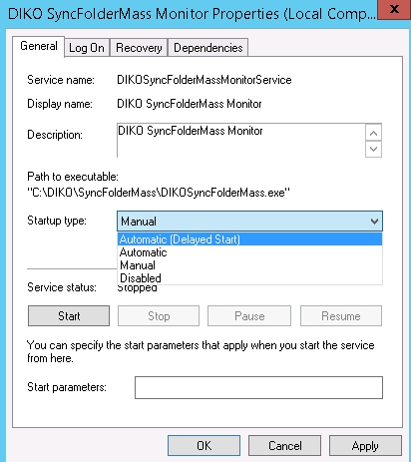

15.11 Click Start to Start the DIKO Folder Mass Sync Monitor

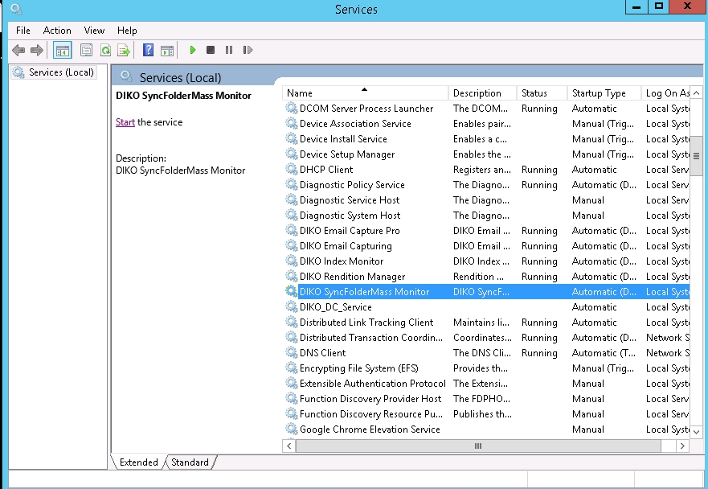

**16 Browse and login DIKO**

16.1 Open Web browser (e.g.: Chrome), input address “http://127.0.0.1/diko/index.aspx”, input admin as the Login ID & 12345 as the password. Finally, click [Login] or Press Enter Key

